PROJECT REPORT ON

Attendance Management System

M.Sc. I.T. (2019-2021)

Prepared by

Vataliya Yatharth

Project Guide

Dr. Vaishali Desai

**Report Submitted To**

Department of Computer science

Saurashtra university

|  |  |  |  |
| --- | --- | --- | --- |
| **Chapter** | **Description** | | **Page No.** |
| **Chapter-1** | **Introduction** | | 2 |
|  | 1.1 | Project Summary | 3 |
|  | 1.2 | Project Overview | 4 |
|  | 1.3 | Purpose and Scope | 5 |
|  | 1.4 | Technology Description | 6 |
|  |  |  |  |
| **Chapter-2** | **Project Management** | | 15 |
|  | 2.1 | Project Plan | 16 |
|  | 2.2 | Roles and Responsibilities | 17 |
|  |  |  |  |
| **Chapter-3** | **System Requirements and Study** | | 18 |
|  | 3.1 | Hardware and Software Requirements | 19 |
|  | 3.2 | Constraints | 21 |
|  |  |  |  |
| **Chapter-4** | **System Analysis** | | 22 |
|  | 4.1 | Feasibility Study | 23 |
|  | 4.2 | Data Modeling | 24 |
|  | 4.3 | Data Dictionary | 34 |
|  |  |  |  |
| **Chapter-5** | **Implementation Planning and Details** | | 41 |
|  | 5.1 | Program Module Specifications | 42 |
|  |  |  |  |
| **Chapter-6** | **Testing** | | 43 |
|  | 6.1 | Testing Strategy | 44 |
|  | 6.2 | Testing Method | 45 |
|  |  |  |  |
| **Chapter-7** | **Screenshots and Bibliography** | | 48 |
|  | 7.1 | Screenshots | 49 |
|  | 7.2 | Bibliography | 56 |

**Chapter-1**

**Introduction**

1.1 Project Summary

1.2 Project Overview

1.3 Purpose and Scope

1.4 Technology Description

**Project Summary**

We are making attendance management system for Educational Institution. It is specially designed for particular school that went to make their attendance system fly on web power. Student attendance management system deals with the maintenance of the student's attendance details. PHP is use as back-end design and MySql is used for front -end side .it is generates the attendance of the student on basis of presence in class. It is maintained on the daily basis of their attendance. The staff will be provided with the separate username & password to make the student's status. The staffs are responsible to fill subject wise attendance for all students. Only if the student present on that particular period, the attendance will be calculated. It can generate weekly, daily or as per faculty requirement reports are generated. Student attendance play significant role in order to justify academic outcome of a student and school as overall. Unfortunately, there is no automated attendance record keeping application available in schools. The only thing to be done is making an environment with an effective supervision. It is cost effective in the sense that has eliminated the paper work completely. The system is also time effective because the calculations are automated which are made at end of the month or as per the user requirement.

**Project Overview**

**Name**

**Attendance Management System**

**Front-end**

**Laravel**

**Back-end**

**MYSQL**

**Duration**

**3 Months**

**Purpose**

**Manage School Attendance**

**Scope**

**Educational Institute**

**Purpose and Scope**

1. Purpose
   1. The purpose of developing attendance management system is to computerized the tradition way of taking attendance.
   2. Another purpose for developing this software is to generate the report automatically at the end of the session or in the between of the session.
2. Scope
   1. This project is not for public use.
   2. This will be used for any given institution only.
   3. Only admin/in charge and teachers of that given educational institution.

**Technology Description**

**Laravel**



Laravel is an open-source PHP framework, which is robust and easy to understand. It follows a model-view-controller design pattern. Laravel reuses the existing components of different frameworks which helps in creating a web application. The web application thus designed is more structured and pragmatic.

Laravel offers a rich set of functionalities which incorporates the basic features of PHP frameworks like CodeIgniter, Yii and other programming languages like Ruby on Rails. Laravel has a very rich set of features which will boost the speed of web development.

If you are familiar with Core PHP and Advanced PHP, Laravel will make your task easier. It saves a lot time if you are planning to develop a website from scratch. Moreover, a website built in Laravel is secure and prevents several web attacks.

* **Advantages of Laravel**

Laravel offers you the following advantages, when you are designing a web application based on it −

* The web application becomes more scalable, owing to the Laravel framework.
* Considerable time is saved in designing the web application, since Laravel reuses the components from other framework in developing web application.
* It includes namespaces and interfaces, thus helps to organize and manage resources.

Laravel offers the following key features which make it an ideal choice for designing web applications −

* **Modularity**
* **Testability**
* **Routing**
* **Configuration Management**
* **Query Builder and ORM**
* **Schema Builder**
* **Template Engine**
* **E-mail**
* **Authentication**
* **Redis**
* **Queues**
* **Event and Command Bus**

# Laravel - Application Structure

The application structure in Laravel is basically the structure of folders, sub-folders and files included in a project. Once we create a project in Laravel, we get an overview of the application structure as shown in the image here.

The snapshot shown here refers to the root folder of Laravel namely **laravel-project**. It includes various sub-folders and files. The analysis of folders and files, along with their functional aspects is given below −

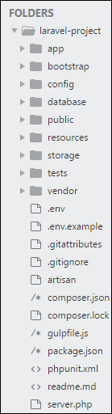

* **App**

It is the application folder and includes the entire source code of the project. It contains events, exceptions and middleware declaration. The app folder comprises various sub folders as explained below −

* **Console**

Console includes the artisan commands necessary for Laravel.

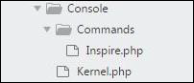

* **Events**

This folder includes all the events for the project. Events are used to trigger activities, raise errors or necessary validations and provide greater flexibility.

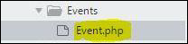

* **Exceptions**

This folder contains all the methods needed to handle exceptions. It also contains the file **handle.php** that handles all the exceptions.

* **Http**

The **Http** folder has sub-folders for controllers, middleware and application requests. As Laravel follows the MVC design pattern, this folder includes model, controllers and views defined for the specific directories.

* **Bootstrap**

This folder encloses all the application bootstrap scripts. It contains a sub-folder namely **cache**, which includes all the files associated for caching a web application. You can also find the file **app.php**, which initializes the scripts necessary for bootstrap.

* **Config**

The **config** folder includes various configurations and associated parameters required for the smooth functioning of a Laravel application. Various files included within the config folder are as shown in the image here. The filenames work as per the functionality associated with them.

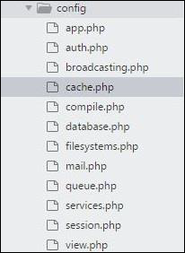

* **Database**

As the name suggests, this directory includes various parameters for database functionalities. It includes three sub-directories as given below −

* **Seeds** − This contains the classes used for unit testing database.
* **Migrations** − This folder helps in queries for migrating the database used in the web application.
* **Factories** − This folder is used to generate large number of data records.
* **Public**

It is the root folder which helps in initializing the Laravel application. It includes the following files and folders −

* **.htaccess** − This file gives the server configuration.
* **javascript and css** − These files are considered as assets.
* **index.php** − This file is required for the initialization of a web application.
* **Resources**

Resources directory contains the files which enhances your web application. The sub-folders included in this directory and their purpose is explained below −

* **assets** − The assets folder include files such as LESS and SCSS, that are required for styling the web application.
* **lang** − This folder includes configuration for localization or internalization.
* **views** − Views are the HTML files or templates which interact with end users and play a primary role in MVC architecture.
* **Storage**

This is the folder that stores all the logs and necessary files which are needed frequently when a Laravel project is running. The sub-folders included in this directory and their purpose is given below −

* **app** − This folder contains the files that are called in succession.
* **framework** − It contains sessions, cache and views which are called frequently.
* **Logs** − All exceptions and error logs are tracked in this sub folder.
* **Tests**

All the unit test cases are included in this directory. The naming convention for naming test case classes is **camel\_case** and follows the convention as per the functionality of the class.

* **Vendor**

Laravel is completely based on Composer dependencies, for example to install Laravel setup or to include third party libraries, etc. The Vendor folder includes all the composer dependencies.

**CSS Framework:**

Having a solid CSS framework as part for your project is an important foundational addition. While it's fun to roll your own CSS foundation/framework, it is also a good option having a third-party framework like Bootstrap or Bulma. A third-party CSS framework allows for:

* Uniformity across teams of developers
* Documented features
* New features are added by the package owner or community
* A set of classes and components

**Bootstrap**

* Bootstrap is a web framework that focuses on simplifying the development of informative web pages (as opposed to [web apps](https://en.wikipedia.org/wiki/Web_Apps)).
* The primary purpose of adding it to a web project is to apply Bootstrap's choices of color, size, font and layout to that project.
* As such, the primary factor is whether the developers in charge find those choices to their liking.
* Once added to a project, Bootstrap provides basic style definitions for all [HTML elements](https://en.wikipedia.org/wiki/HTML_element).
* The end result is a uniform appearance for prose, tables and form elements across [web browsers](https://en.wikipedia.org/wiki/Web_browser).
* In addition, developers can take advantage of CSS classes defined in Bootstrap to further customize the appearance of their contents.
* For example, Bootstrap has provisioned for light- and dark-colored tables, page headings, more prominent pull quotes, and text with a highlight.

**PHP**

**PHP: Hypertext Preprocessor** (or simply **PHP**) is a [general-purpose programming language](https://en.wikipedia.org/wiki/General-purpose_programming_language) originally designed for [web development](https://en.wikipedia.org/wiki/Web_development).

PHP code may be executed with a [command line interface](https://en.wikipedia.org/wiki/Command-line_interface) (CLI), embedded into [HTML](https://en.wikipedia.org/wiki/HTML) code, or it can be used in combination with various [web template systems](https://en.wikipedia.org/wiki/Web_template_system), web content management systems, and [web frameworks](https://en.wikipedia.org/wiki/Web_framework).

PHP has been widely ported and can be deployed on most web servers on almost every [operating system](https://en.wikipedia.org/wiki/Operating_system) and [platform](https://en.wikipedia.org/wiki/Computing_platform), free of charge

The web server combines the results of the interpreted and executed PHP code, which may be any type of data, including images, with the generated web page.

PHP can be used for many programming tasks outside of the web context, such as [standalone](https://en.wikipedia.org/wiki/Computer_software) [graphical applications](https://en.wikipedia.org/wiki/Graphical_user_interface)

PHP 7 also included new language features.

Most notably, it introduces return type declarations for functionswhich complement the existing parameter type declarations, and support for the [scalar](https://en.wikipedia.org/wiki/Variable_(computer_science)) types (integer, float, string, and boolean) in parameter and return type declarations.[[](https://en.wikipedia.org/wiki/PHP" \l "cite_note-scalar-types-63)

**MYSQL**

MySQL is an [open source](https://en.wikipedia.org/wiki/Open-source_software) relational database management system (RDBMS).

The MySQL server software itself and the client libraries use [dual-licensing](https://en.wikipedia.org/wiki/Dual_license) distribution.

MySQL is offered under two different editions: the [open source](https://en.wikipedia.org/wiki/Open-source_software) MySQL Community Server and the proprietary [Enterprise Server](https://en.wikipedia.org/wiki/MySQL_Enterprise).

Major features as available in MySQL 5.6:

* Cross-platform support
* [Stored procedures](https://en.wikipedia.org/wiki/Stored_procedure), using a procedural language that closely adheres to [SQL/PSM](https://en.wikipedia.org/wiki/SQL/PSM)[[75]](https://en.wikipedia.org/wiki/MySQL" \l "cite_note-HarrisonFeuerstein2008-75)
* [Triggers](https://en.wikipedia.org/wiki/Database_trigger)
* [Cursors](https://en.wikipedia.org/wiki/Cursor_(databases))
* Updatable [views](https://en.wikipedia.org/wiki/View_(SQL))
* Online [Data Definition Language](https://en.wikipedia.org/wiki/Data_Definition_Language) (DDL) when using the InnoDB Storage Engine.

Multiple storage engines, allowing one to choose the one that is most effective for each table in the application.

**Chapter-2**

**Project Management**

2.1 Project Plan

2.2 Roles and Responsibilities

**Project Plan**

We decided definition in June end, and analyzed project in whole semester, from June to October. In project analysis initially wrote the summary of project, and started making use case diagrams, DFD(Data Flow Diagram) and ERD(Entity Relationship Diagram).

Afterwards we noted down whole database on paper and assessed it. After database was finalized, we drew form designs on paper.

In next semester, i.e. from December to March, we were in development and testing phase of the project. We decided framework and backend languages, and started designing project. Afterwards we started developing and linking project with database. After that we tested our project and made document of it.

**Roles and Responsibilities**

Yatharth Vataliya

I was developer in this project. I also partially designed project and completed integration of modules with the system, testing modules.

My main task was code implementation, user rights management and generating reports.

Also I am analyst and designer in this project. Task was to analyze whole project, make DFD(Data Flow Diagram), ERD(Entity Relationship Diagram) and Use Cases, which would be essential in development of project.

**Chapter-3**

**System Requirements and Study**

3.1 Hardware and Software Requirements

3.2 Constraints

**Hardware and Software Requirements**

Hardware Requirement-

|  |  |
| --- | --- |
| Processor | Dual Core |
| Network | Active internet/Local Server Connection |

Software Requirement-

|  |  |
| --- | --- |
| Operating System | Any O.S. with Browser |
| Front-end Technologies | Laravel |
| Back-end Technologies | MySQL |
| Client Side Scripting Language | HTML/CSS |
| Server Side Scripting Language | PHP |
| Browser | Compatible with current Front-end languages |

Software Description:

|  |  |  |
| --- | --- | --- |
| Sr. | Software | Use |
| 1 | Laravel | PHP Application Framework |
| 2 | PHP | Server side Scripting Language |
| 3 | MySql | Database |
| 4 | Notepad++ | Used as an Editor |
| 5 | Sublime | Used as an Editor |
| 6 | PhpStrom | Used as an IDE |
| 7 | O.S. | For opening browser |
| 8 | Web Browser | For opening web application |
| 9 | Selenium (Firefox Extension) | For Testing Purpose |

**Constraints**

* Internet connectivity is must.
* Browser should support modern scripting languages.
* JavaScript should be enabled.
* Currently this application is independent, and not dependent on any other applications.
* This application is designed for normal users, so currently basic authentication feature is implemented.

**Chapter-4**

**System Analysis**

4.1 Feasibility Study

4.2 Data Modeling

4.3 Data Dictionary

**Feasibility Study**

* It is feasible for most of the users as it only need basic knowledge of computer operations or mobile operations.
* It does not cost extra in terms of hardware to the users or institution.
* Additional training will not be needed as the UI (User Interface) is easy to understand.
* Basic instructions are enough to operate this web application.
* The system is technically feasible as the technical requirements are very minimal, that is it only needs basic hardware and software system to operate on.
* Also it has operation feasibility as software is easily configured with hardware because this system only needs browser which is built in or easily installed.
* The functionalities in this project are designed such that the novice users can also easily understand.

**Data Modeling**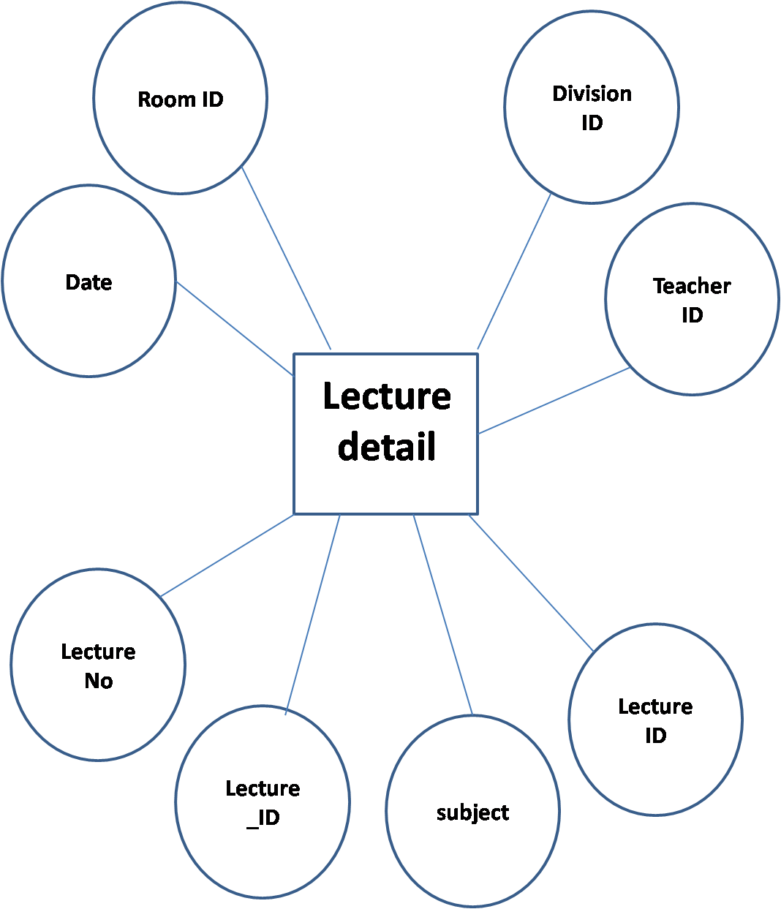

**DFD**

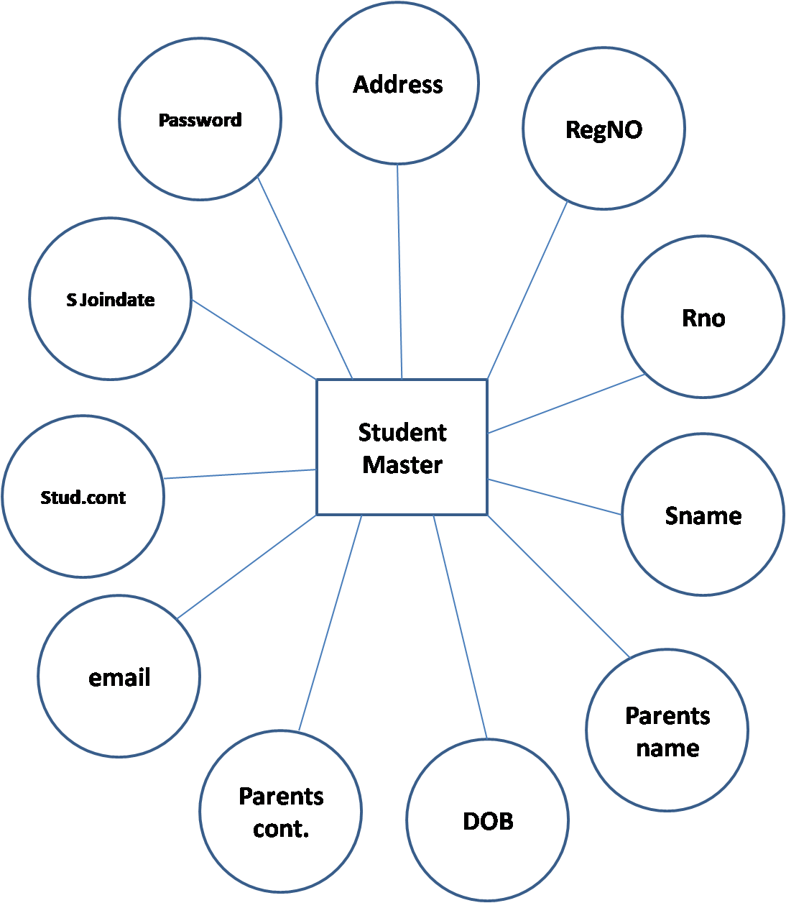

**DFD**

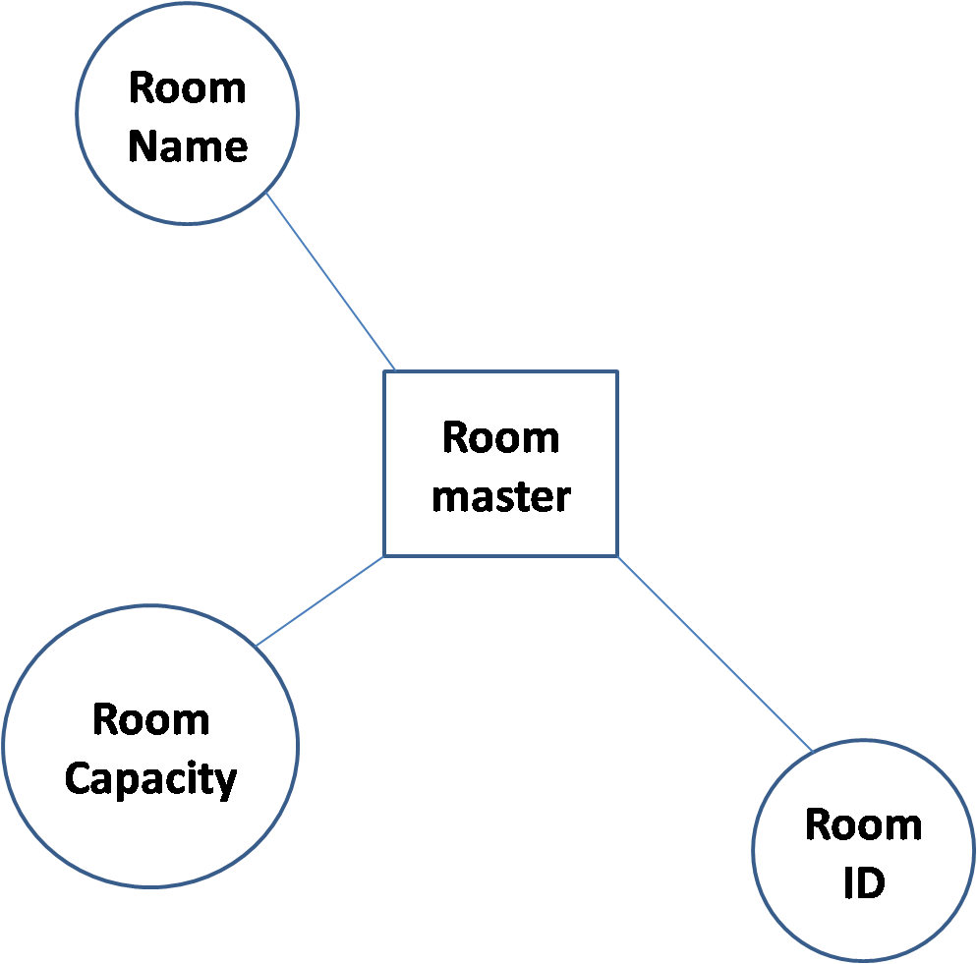

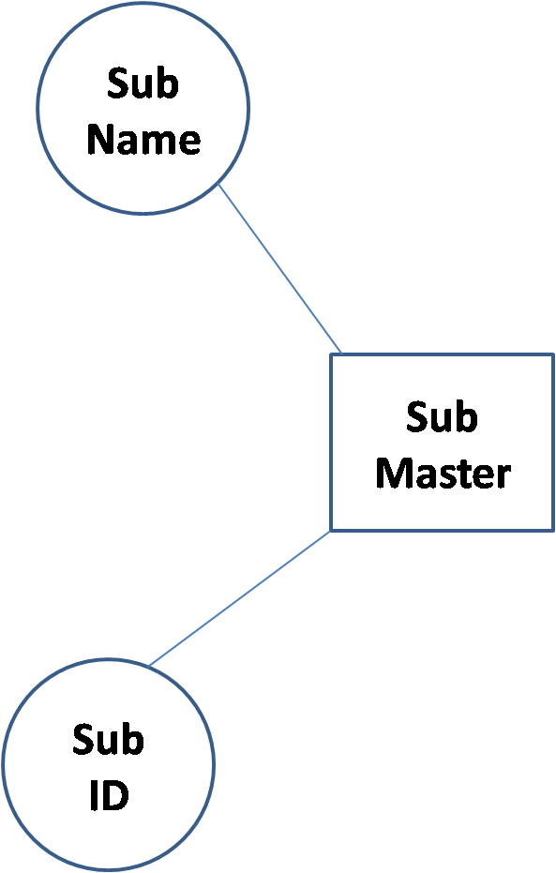 **DFD** 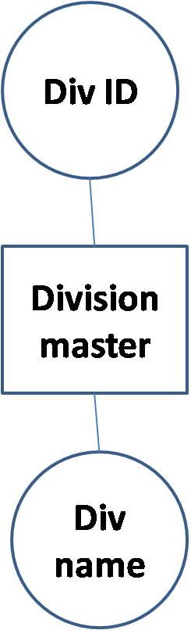

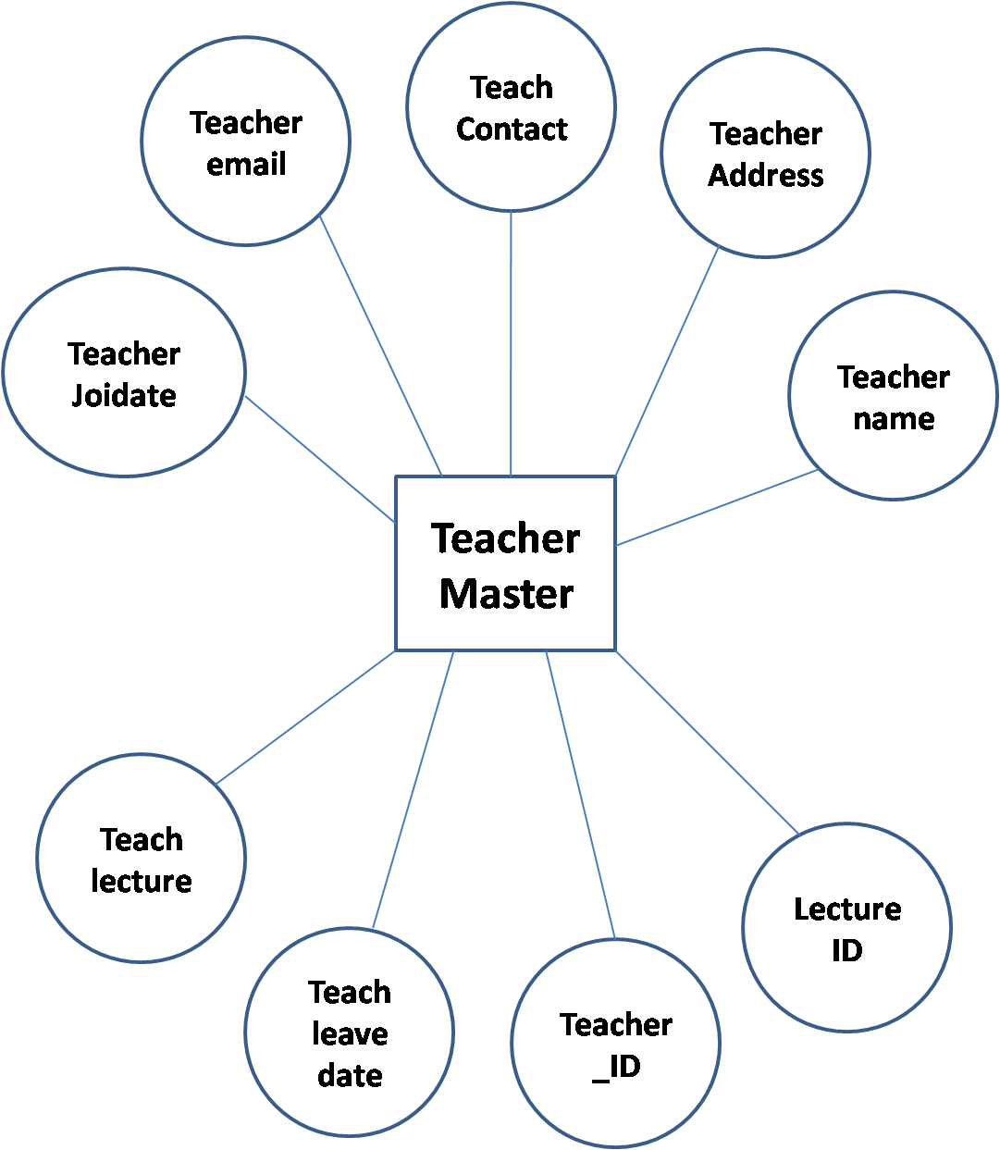

**DFD**

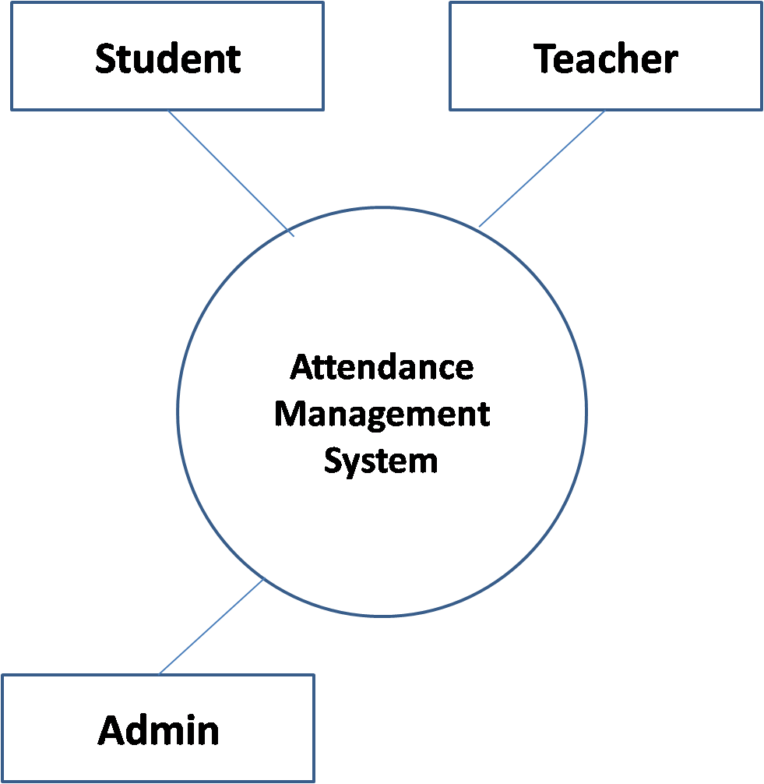

**DFD**

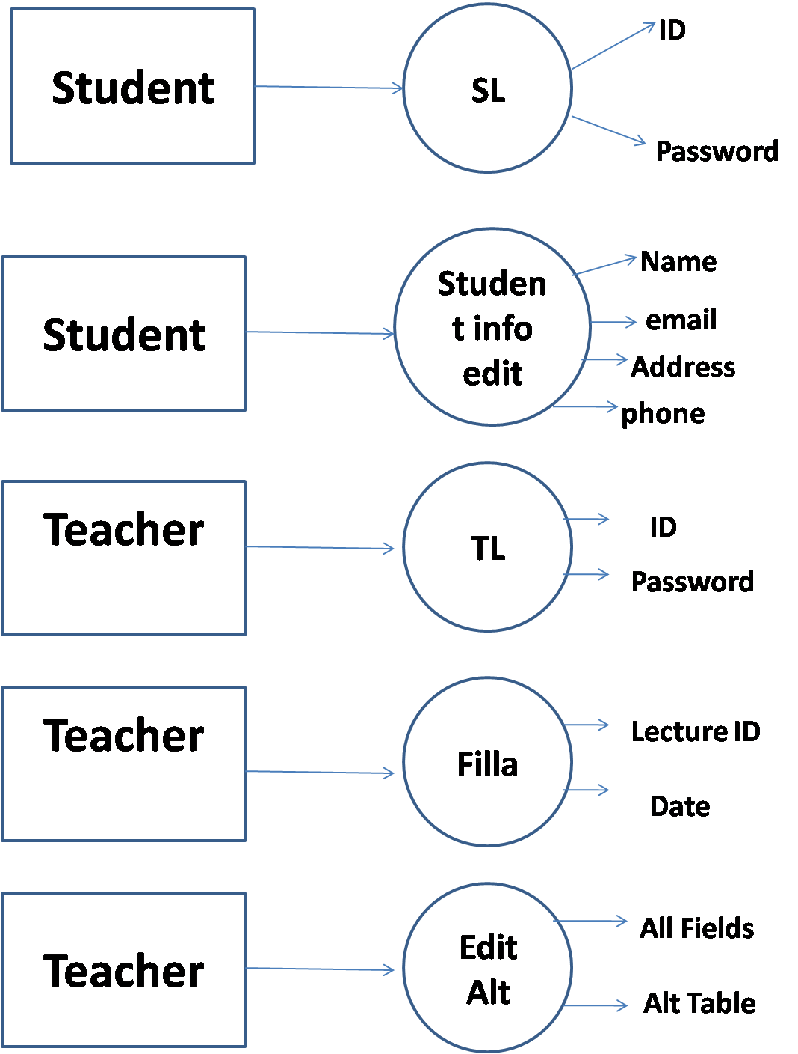

**DFD**

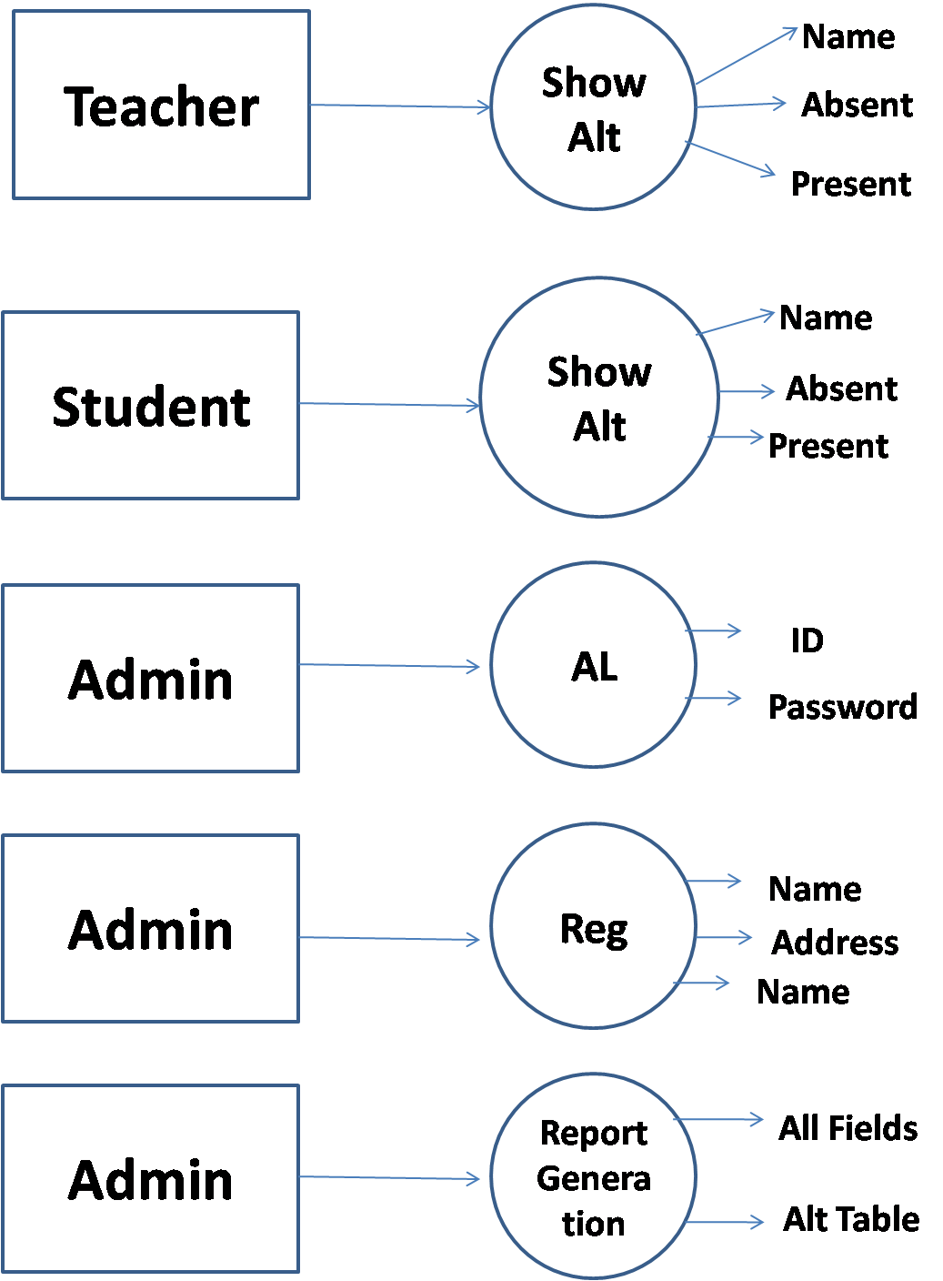

**DFD**

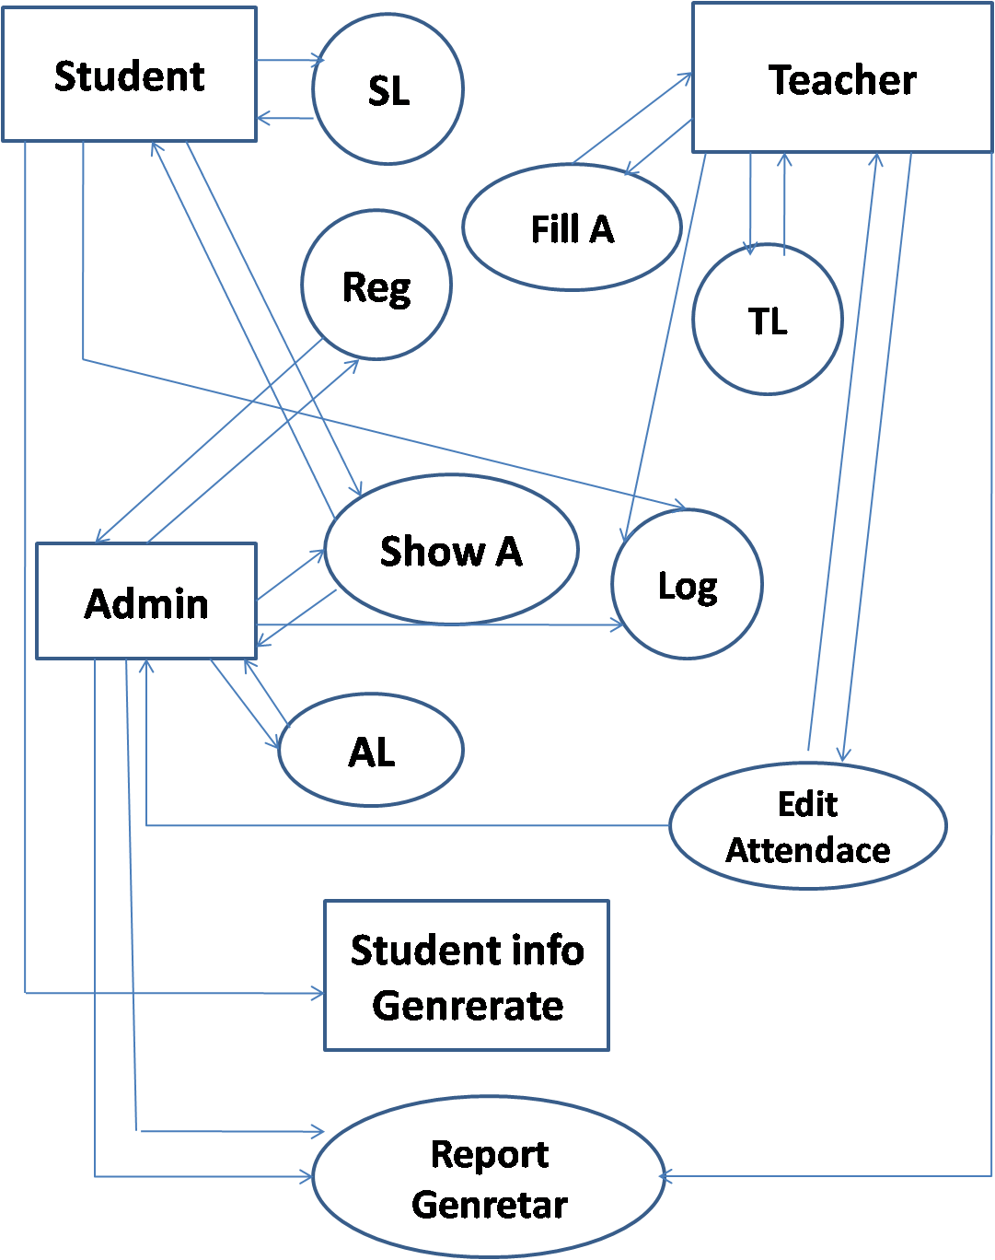

E-R Diagram

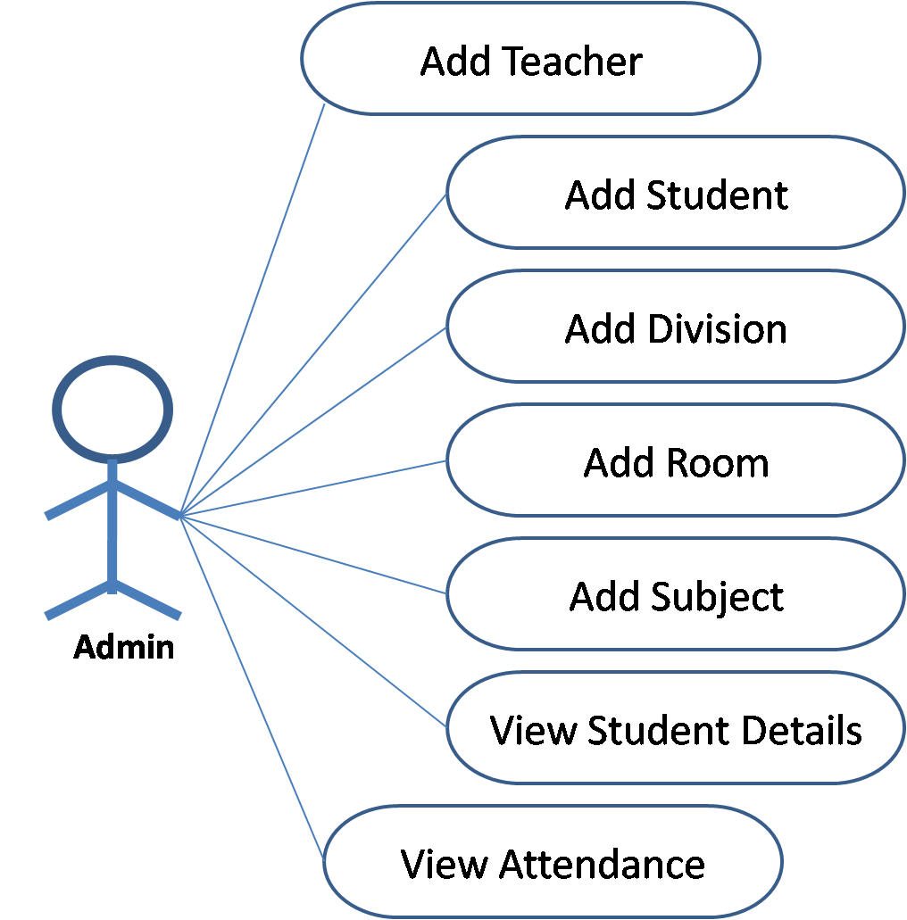

**Use Case Diagram**

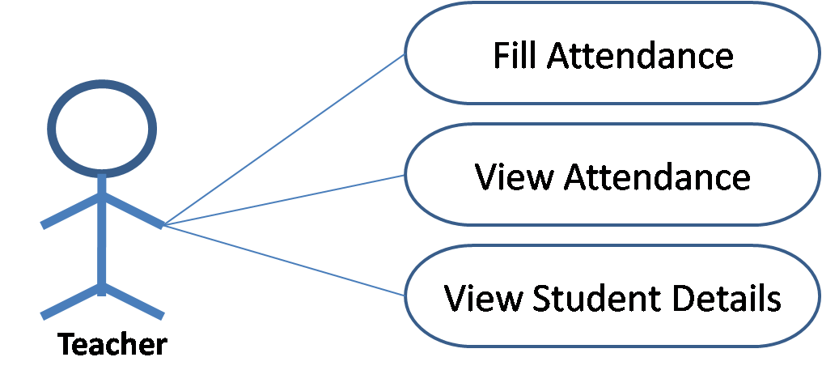

**Use Case Diagram**

**Data Dictionary**

Complete view of whole database

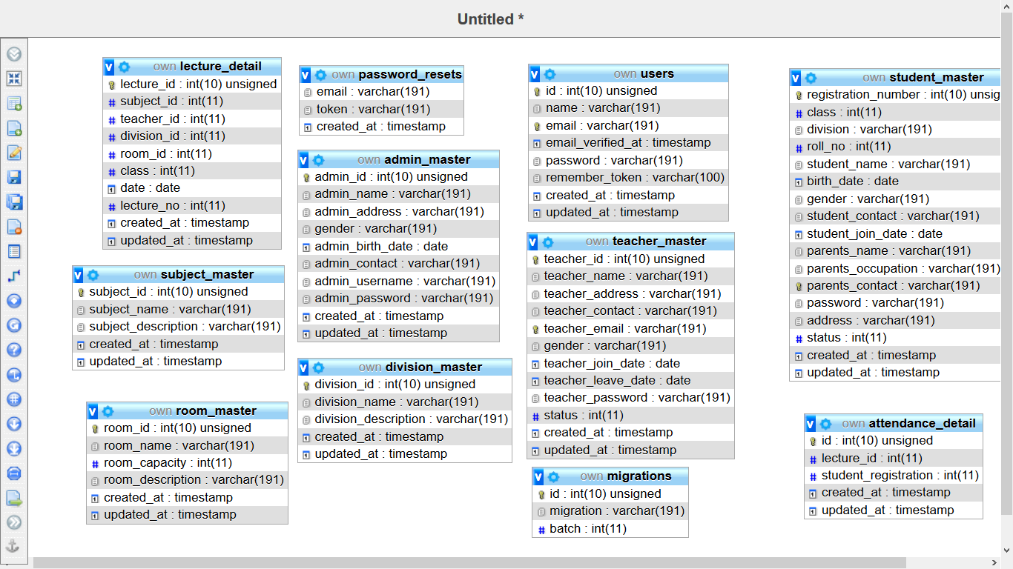

admin\_master

|  |  |  |  |
| --- | --- | --- | --- |
| **Sr.** | **Name** | **Type** | **Null** |
| 1 | **admin\_id** | int(10) | No |
| 2 | **admin\_name** | varchar(191) | No |
| 3 | **admin\_address** | varchar(191) | No |
| 4 | **gender** | varchar(191) | No |
| 5 | **admin\_birth\_date** | date | No |
| 6 | **admin\_contact** | varchar(191) | No |
| 7 | **admin\_username** | varchar(191) | No |
| 8 | **admin\_password** | varchar(191) | No |
| 9 | **created\_at** | timestamp | Yes |
| 10 | **updated\_at** | timestamp | Yes |

admin\_name

|  |  |  |  |
| --- | --- | --- | --- |
| **Sr.** | **Name** | **Type** | **Null** |
| 1 | **id** | int(10) | No |
| 2 | **lecture\_id** | int(11) | No |
| 3 | **student\_registration** | int(11) | No |
| 4 | **created\_at** | timestamp | Yes |
| 5 | **updated\_at** | timestamp | Yes |

division\_master

|  |  |  |  |
| --- | --- | --- | --- |
| **Sr.** | **Name** | **Type** | **Null** |
| 1 | **division\_id** | int(10) | No |
| 2 | **division\_name** | varchar(191) | No |
| 3 | **division\_description** | varchar(191) | Yes |
| 4 | **created\_at** | timestamp | Yes |
| 5 | **updated\_at** | timestamp | Yes |

lecture\_detail

|  |  |  |  |
| --- | --- | --- | --- |
| **Sr.** | **Name** | **Type** | **Null** |
| 1 | **lecture\_id** | int(10) | No |
| 2 | **subject\_id** | int(11) | No |
| 3 | **teacher\_id** | int(11) | No |
| 4 | **division\_id** | int(11) | Yes |
| 5 | **room\_id** | int(11) | No |
| 6 | **class** | int(11) | No |
| 7 | **date** | date | No |
| 8 | **lecture\_no** | int(11) | No |
| 9 | **created\_at** | timestamp | Yes |
| 10 | **updated\_at** | timestamp | Yes |

migrations

|  |  |  |  |
| --- | --- | --- | --- |
| **Sr.** | **Name** | **Type** | **Null** |
| 1 | **id** | int(10) | No |
| 2 | **migration** | varchar(191) | No |
| 3 | **batch** | int(11) | No |

password\_resets

|  |  |  |  |
| --- | --- | --- | --- |
| **Sr.** | **Name** | **Type** | **Null** |
| 1 | **email** | varchar(191) | No |
| 2 | **token** | varchar(191) | No |
| 3 | **created\_at** | timestamp | Yes |

room\_master

|  |  |  |  |
| --- | --- | --- | --- |
| **Sr.** | **Name** | **Type** | **Null** |
| 1 | **room\_id** | int(10) | No |
| 2 | **room\_name** | varchar(191) | No |
| 3 | **room\_capacity** | int(11) | No |
| 4 | **room\_description** | varchar(191) | Yes |
| 5 | **created\_at** | timestamp | Yes |
| 6 | **updated\_at** | timestamp | Yes |

student\_master

|  |  |  |  |
| --- | --- | --- | --- |
| **Sr.** | **Name** | **Type** | **Null** |
| 1 | **registration\_number** | int(10) | No |
| 2 | **class** | int(11) | No |
| 3 | **division** | varchar(191) | No |
| 4 | **roll\_no** | int(11) | No |
| 5 | **student\_name** | varchar(191) | No |
| 6 | **birth\_date** | date | No |
| 7 | **gender** | varchar(191) | No |
| 8 | **student\_contact** | varchar(191) | Yes |
| 9 | **student\_join\_date** | date | No |
| 10 | **parents\_name** | varchar(191) | No |
| 11 | **parents\_occupation** | varchar(191) | Yes |
| 12 | **parents\_contact** | varchar(191) | No |
| 13 | **password** | varchar(191) | No |
| 14 | **address** | varchar(191) | No |
| 15 | **status** | int(11) | No |
| 16 | **created\_at** | timestamp | Yes |
| 17 | **updated\_at** | timestamp | Yes |

subject\_master

|  |  |  |  |
| --- | --- | --- | --- |
| **Sr.** | **Name** | **Type** | **Null** |
| 1 | **subject\_id** | int(10) | No |
| 2 | **subject\_name** | varchar(191) | No |
| 3 | **subject\_description** | varchar(191) | Yes |
| 4 | **created\_at** | timestamp | Yes |
| 5 | **updated\_at** | timestamp | Yes |

teacher\_master

|  |  |  |  |
| --- | --- | --- | --- |
| **Sr.** | **Name** | **Type** | **Null** |
| 1 | **teacher\_id** | int(10) | No |
| 2 | **teacher\_name** | varchar(191) | No |
| 3 | **teacher\_address** | varchar(191) | Yes |
| 4 | **teacher\_contact** | varchar(191) | No |
| 5 | **teacher\_email** | varchar(191) | No |
| 6 | **gender** | varchar(191) | No |
| 7 | **teacher\_join\_date** | date | No |
| 8 | **teacher\_leave\_date** | date | Yes |
| 9 | **teacher\_password** | varchar(191) | No |
| 10 | **status** | int(11) | No |
| 11 | **created\_at** | timestamp | Yes |
| 12 | **updated\_at** | timestamp | Yes |

users master

|  |  |  |  |
| --- | --- | --- | --- |
| **Sr.** | **Name** | **Type** | **Null** |
| 1 | **id** | int(10) | No |
| 2 | **name** | varchar(191) | No |
| 3 | **email** | varchar(191) | No |
| 4 | **email\_verified\_at** | timestamp | Yes |
| 5 | **password** | varchar(191) | No |
| 6 | **remember\_token** | varchar(100) | Yes |
| 7 | **created\_at** | timestamp | Yes |
| 8 | **updated\_at** | timestamp | Yes |

**Chapter-5**

**Implementation Planning and Details**

5.1 Program Module Specifications

**Program Module Specifications**

1. Admin
   1. Can add/edit/delete –
      1. Teacher
      2. Student
      3. Subject
      4. Division
      5. Room
   2. Can view all records of all tables
2. Teacher
   1. Can fill attendance
   2. Can view attendance
   3. Can view student profile

**Chapter-6**

**Testing**

6.1 Testing Strategy

6.2 Testing Method

**Testing Strategy**

Testing can be of various types and different types of tests are conducted depending on the kind of bugs one seeks to discover −

**Unit Testing**

Also known as Program Testing, it is a type of testing where the analyst tests or focuses on each program or module independently. It is carried out with the intention of executing each statement of the module at least once.

**Integration Testing**

In Integration Testing, the analyst tests multiple module working together. It is used to find discrepancies between the system and its original objective, current specifications, and systems documentation.

**Functional Testing**

Function testing determines whether the system is functioning correctly according to its specifications and relevant standards documentation. Functional testing typically starts with the implementation of the system, which is very critical for the success of the system.

**Testing Method**

* **Tested in Selenium**

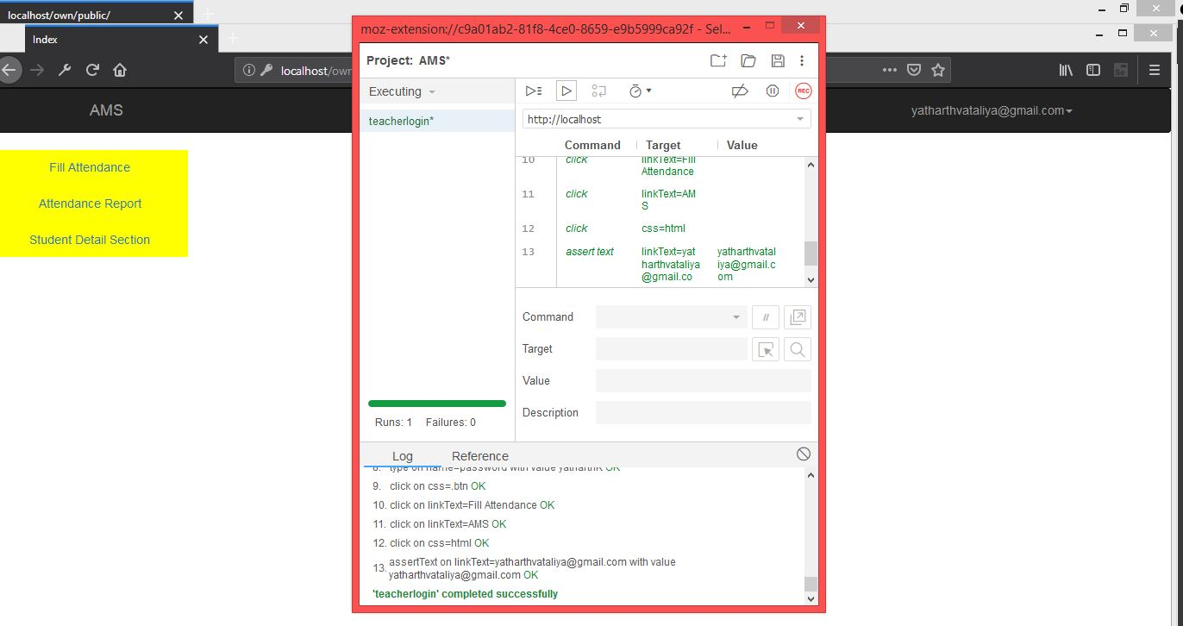

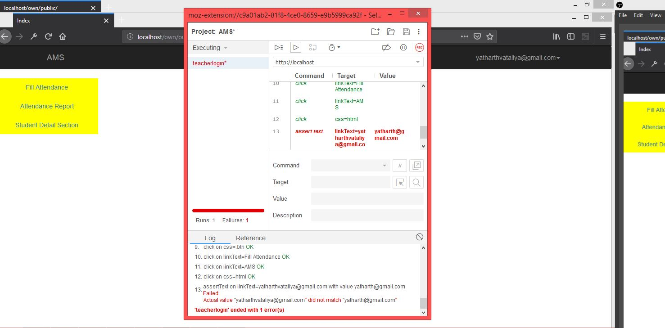

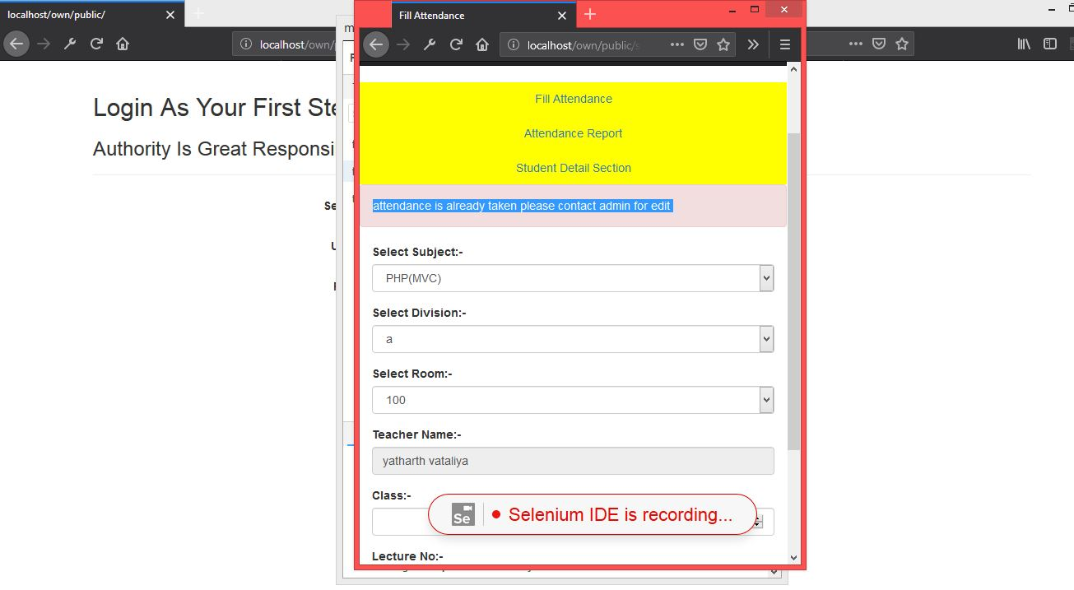

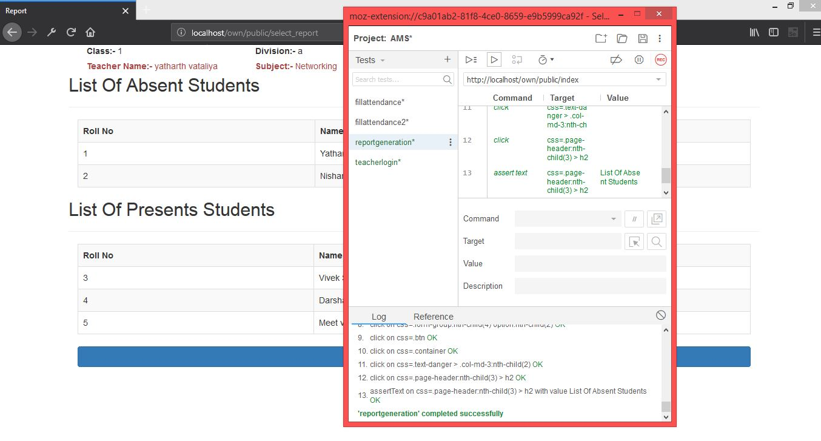

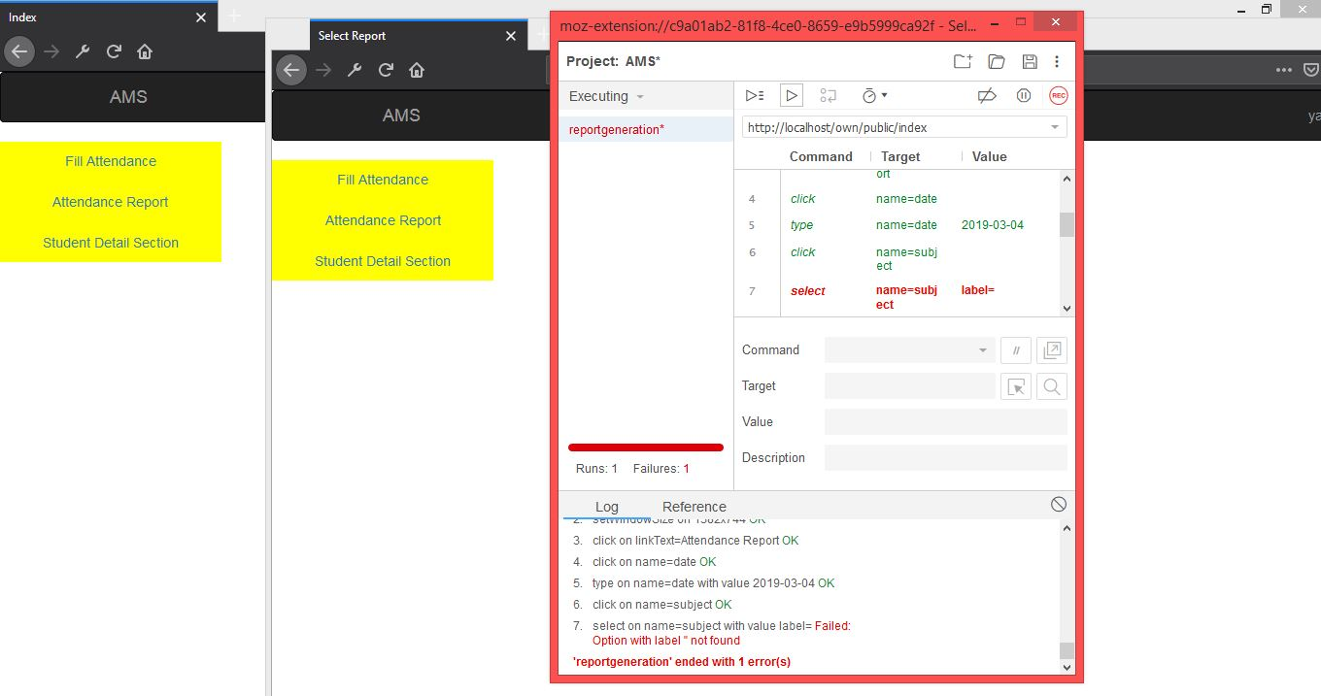

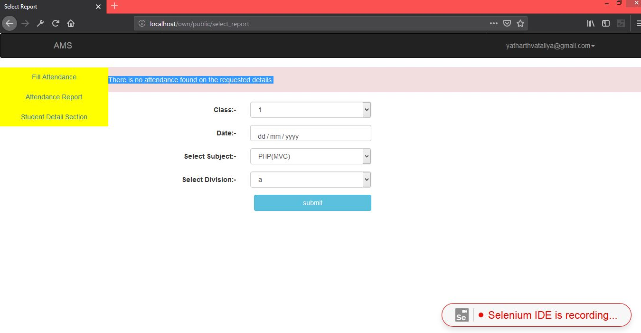

**Chapter-7**

**Screenshots and Bibliography**

7.1 Screenshots

7.2 Bibliography

**Screenshots**

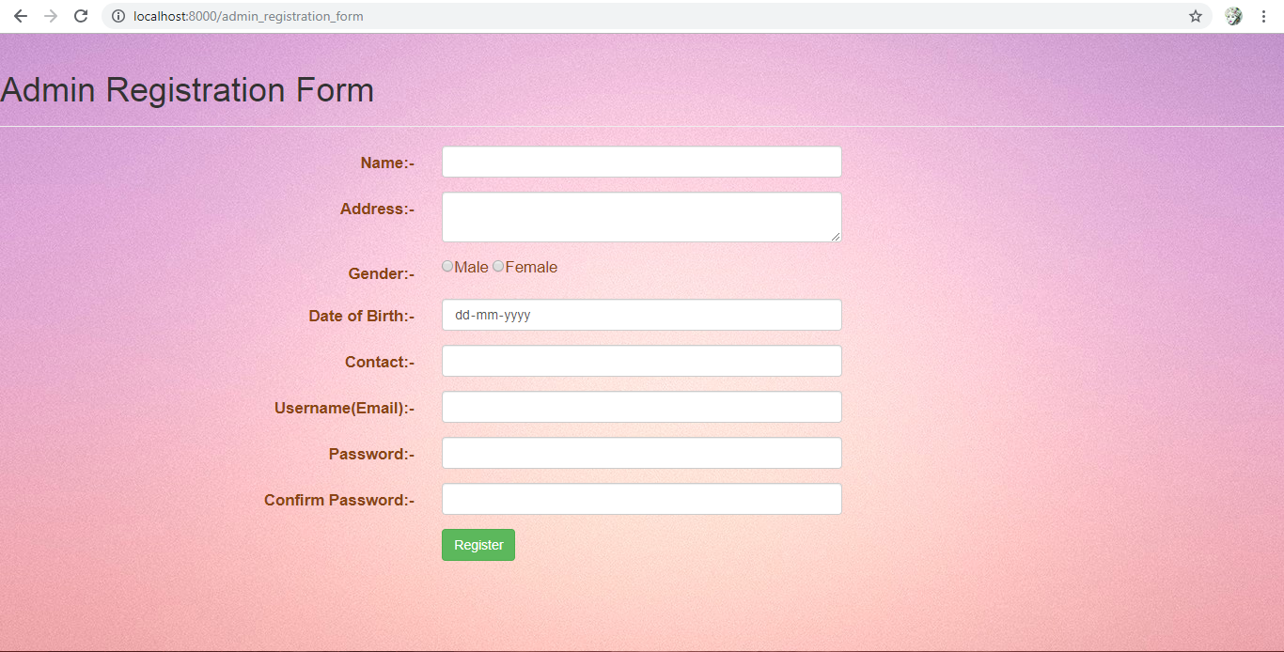

Developer > Admin Registration Form

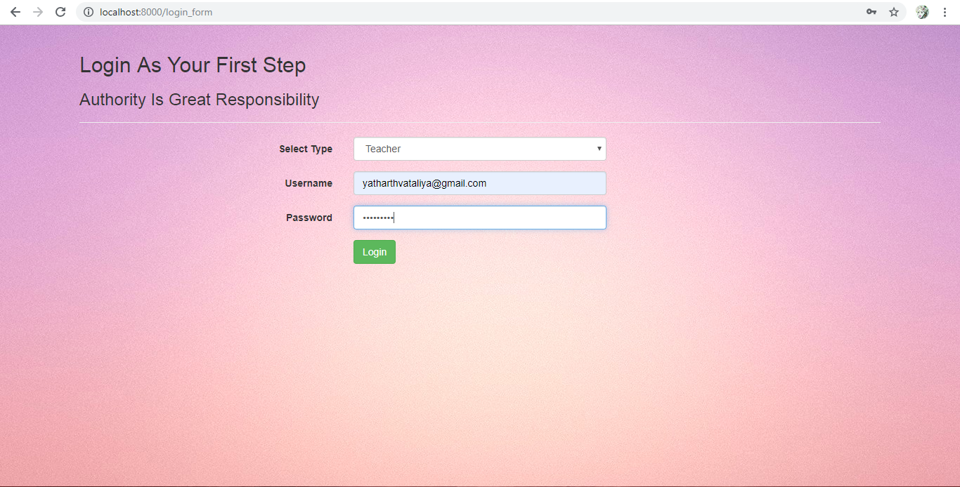

Login Page

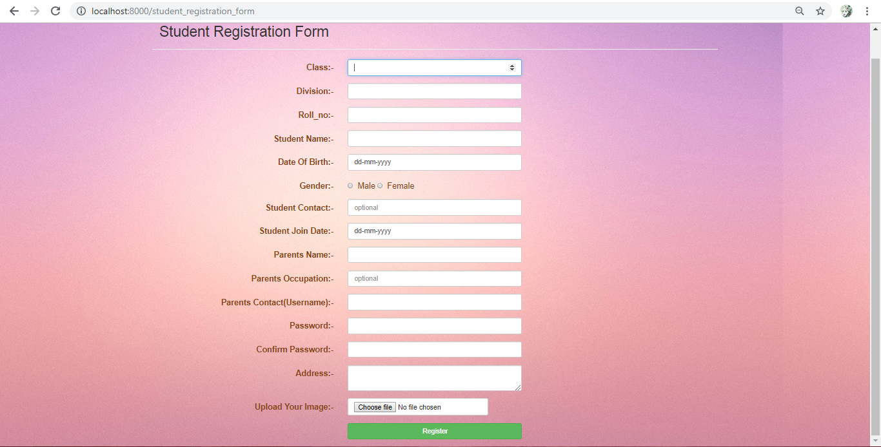

Admin > Student Registration Form

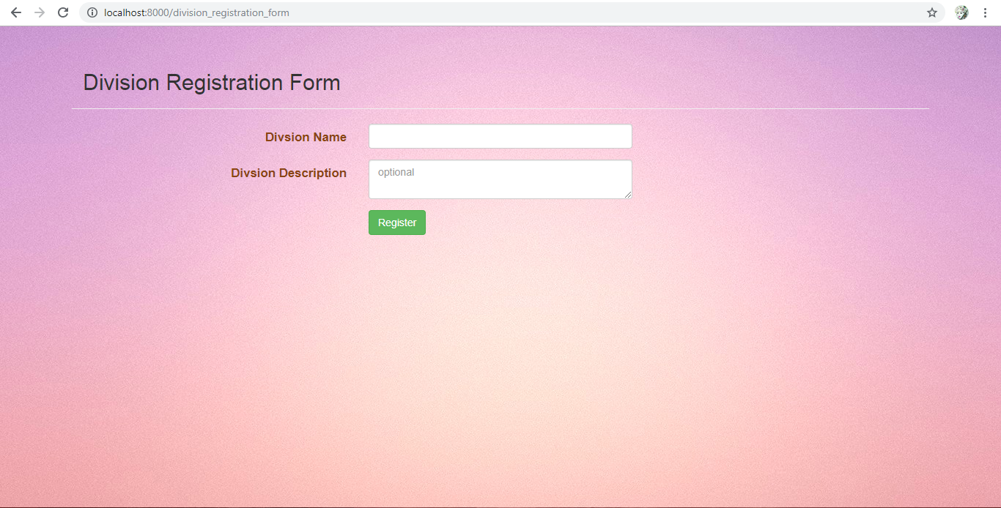

Admin > Division Registration Form

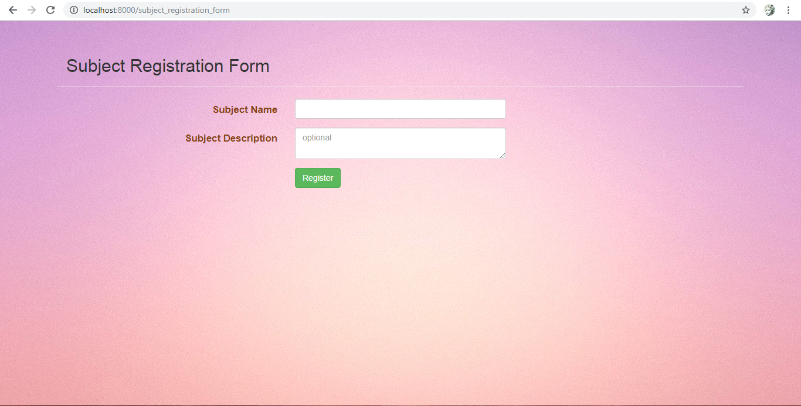

Admin > Subject Registration Form

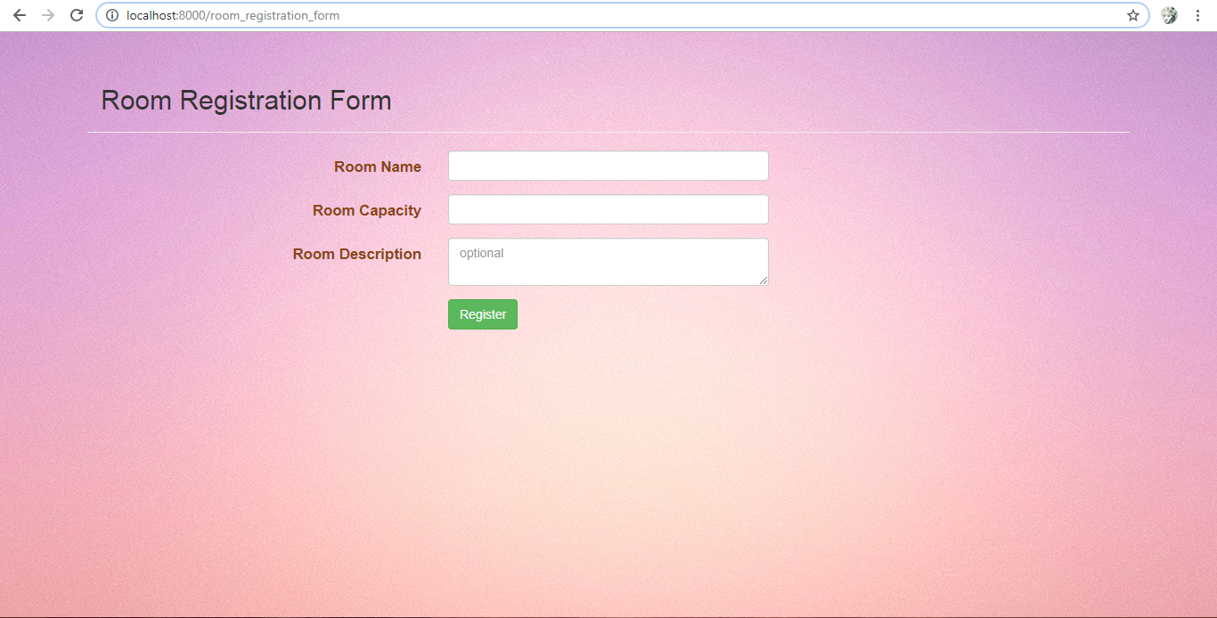

Admin > Room Registration Form

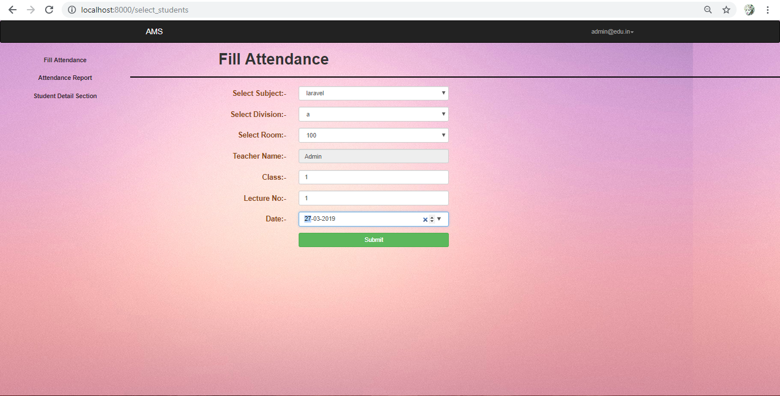

Teacher > Select Class for Attendance

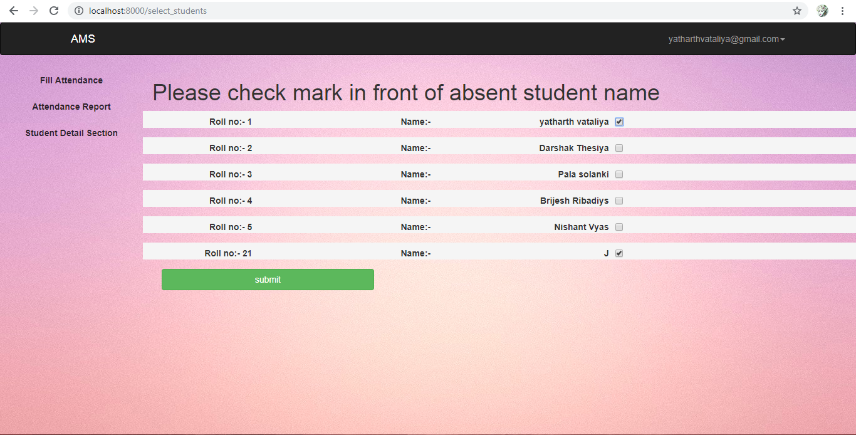

Teacher > Fill Attendance

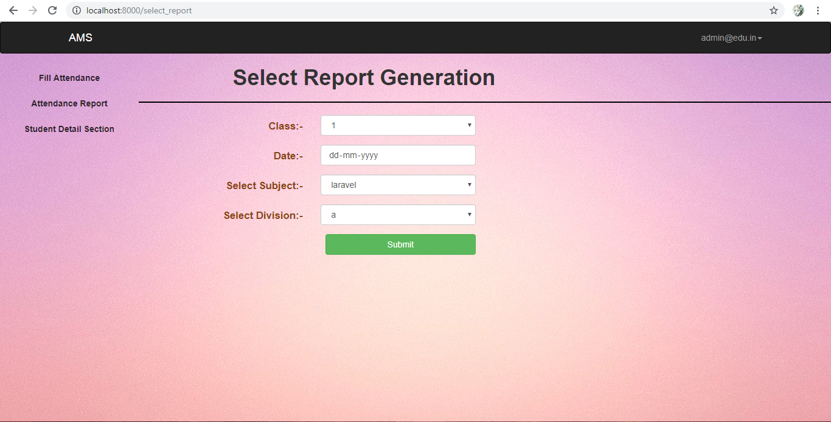

Admin/Teacher > Attendance Report Generation

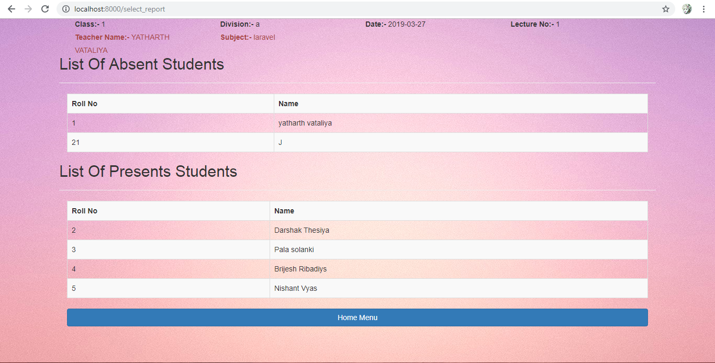

Admin/Teacher > Attendance Report

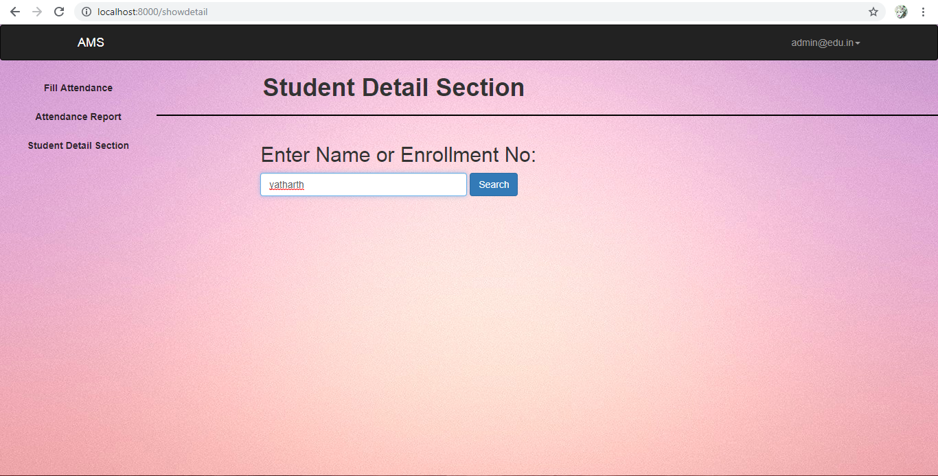

Admin/Teacher > Student Detail Search

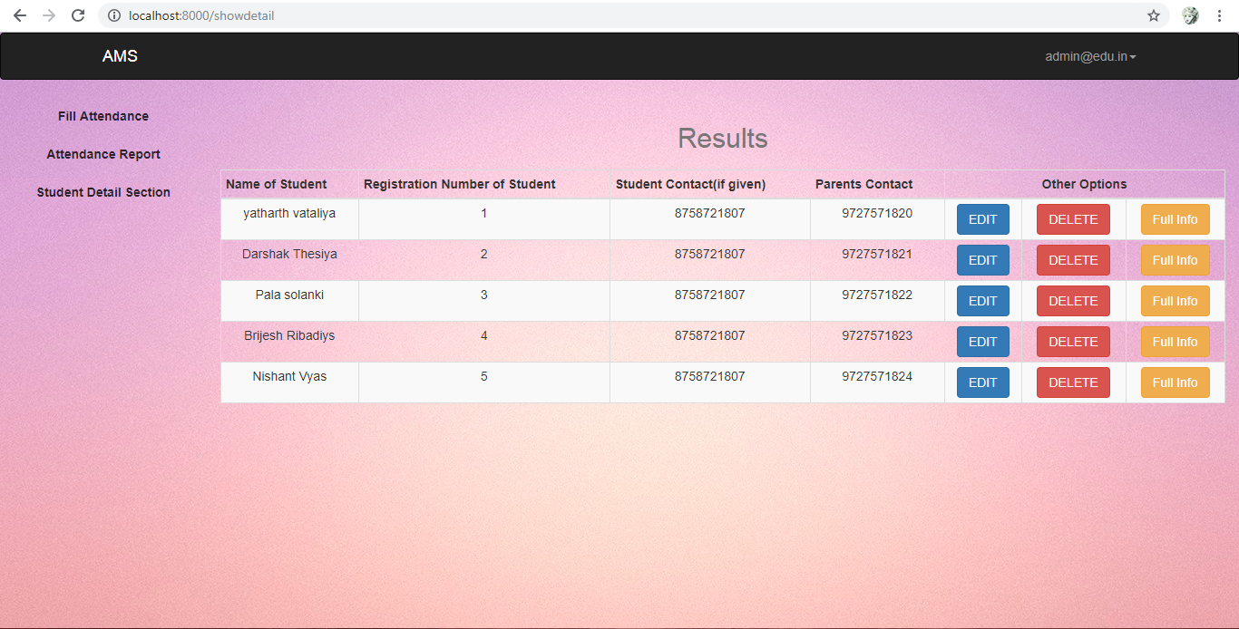

Admin/Teacher > Student Detail

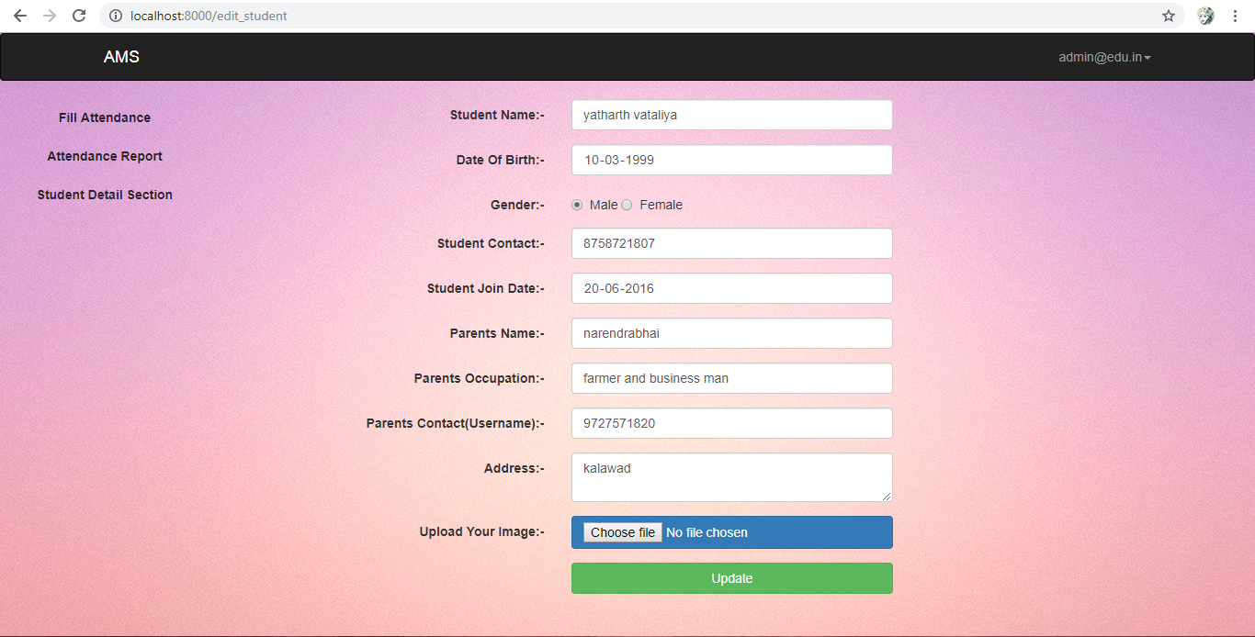

Admin > Edit Student Details

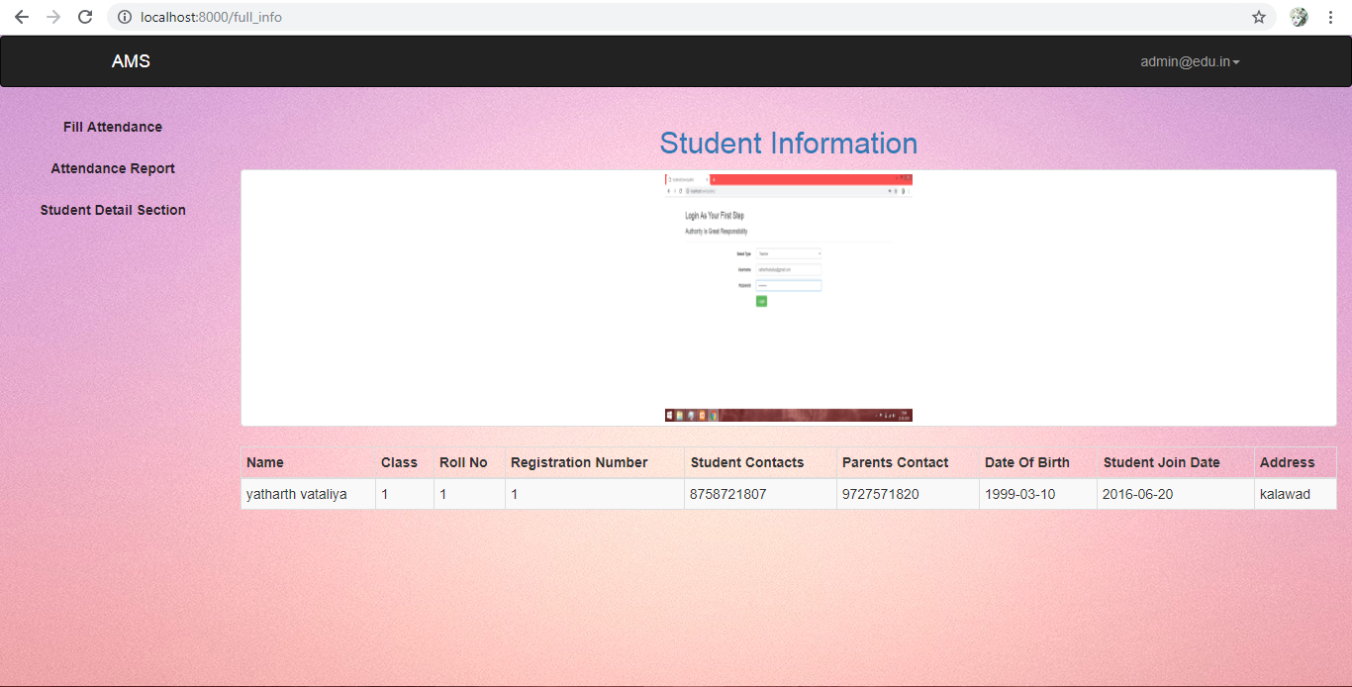

Admin/Teacher > Student Information

**Bibliography**

Reference Sites:

* https://www.laravel.com
* https://www.laracasts.com
* https:// www.stackoverflow.com
* https://www.youtube.com
* https://www.w3schools.com